Email Report – Task 2

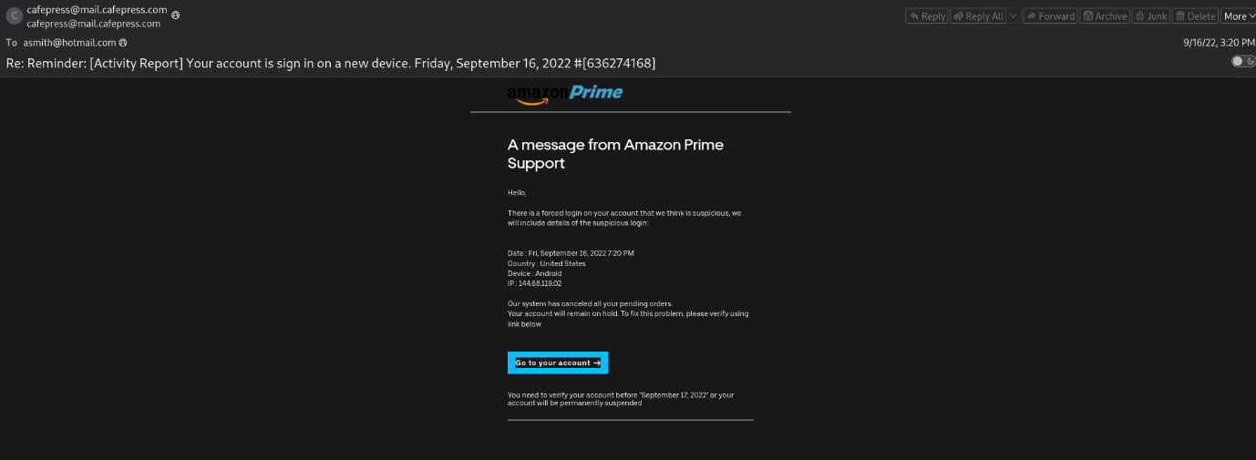
Example Mail:

Headers
======================================
Date: Fri, 16 Sep 2022 19:20:13
Subject: Reminder: [Activity Report] Your account is sign in on a new device. Friday, September 16, 2022 #[636274168]

To:asmith@hotmail.com
From:cafepress@mail.cafepress.com

Return-Path:msprvs1=XjGVrJidPKaSN=bounces-098020-32419@tbh51blx.imdreampores.ovh

Sender IP:209.85.221.104
Resolve Host:mail-wr1-f104.google.com

Message-ID:<Ti6MiLxTCWMiAH1sP7JxbGrEJIqKsD3Nv4CKIa8Mwrs@mail-pf1-f420.googlegroups.com>

URLs
======================================
hxxps[://]cabinetlekagni[.]com/

Description
======================================
This email is claiming to be from Amazon prime support that a unauthorized user login your account and force to click a link to verify the account. This info provide it show a urgence in it.

Artifact Analysis
======================================
Sender Analysis:
Although claiming to be form Amazon Prime the From address is clearly indicate a mailbox from a unrelated domain.
And the resolved host address show that it is originated from a google mail server and also it use a OVH cloud’s domain a Return path which is suspicious.

URL Analysis:
- This URL is found reported malicious by virus total
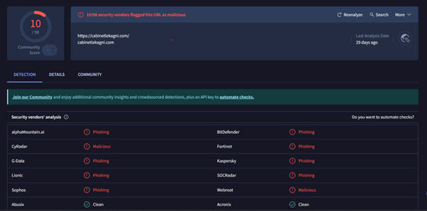

- And also By analysing in urlscan.io it is impersonating the SwissPass to steal the credentials of the victim
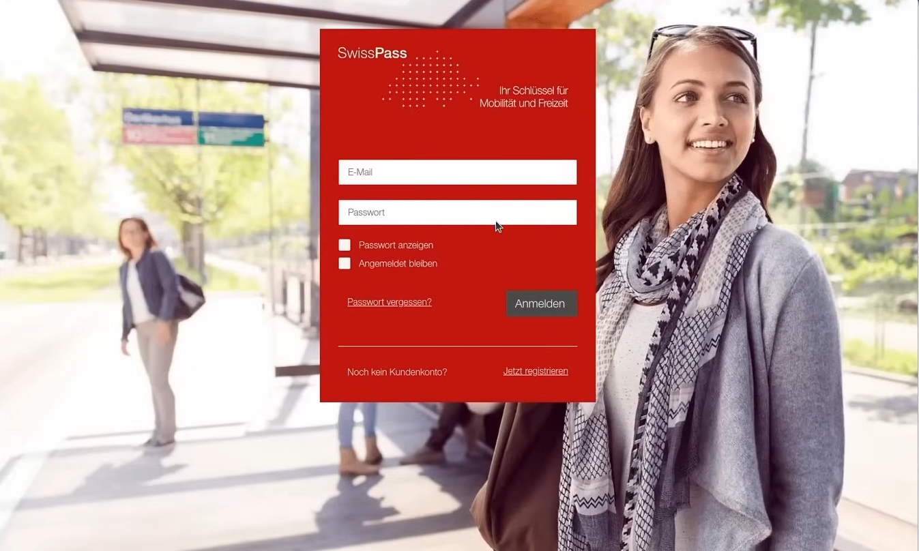

Verdict
======================================
As the Original sender being unaffiliated with Amazon, this email is clearly impersonating and spoofing attempt for capturing the credential of the Victim by using the Link or URL attached in the mail.
The URL is leading as to a credential capture site which is impersonating the Swiss pass.
And also, URL is flagged as malicious by virus total.

